NURETH STAFF USE ONLY
Log #
E-MAILED
MAILED
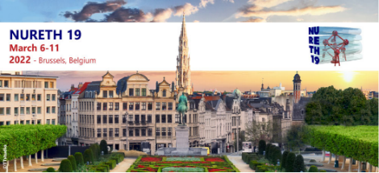

INVITATION LETTER | REQUEST FORM
INSTRUCTIONS and INFORMATION FOR NURETH 19 AUTHORS AND VOLUNTEERS
• You must be listed as an author, chair, or committee member of this conference or your request will not be processed
• If you need to be added to a paper, only the NURETH technical program contact can request to add additional authors to their paper
• Complete one form per person; type the information into this form; hand-written forms will NOT be accepted
• Return this form to the Invitation Letter Processing Department by email: nureth19@sckcen.be
• Requests are processed and sent based on the order received, and the date of the conference
• The invitation letter will be sent to you by email (as a PDF attachment, usually within 3 weeks), and by post if requested
• NURETH 19 is unable to contact Embassies or Consulates in support of an individual attempting to attend the conference
• Data will only be used for the VISA invitation letter and will not be processed further, according to the GDPR.
• We recommend that you secure your travel visa before registering for the conference as cancellations after the registration cutoff may result in a cancellation fee.
Date Form Submitted to NURETH 19: Click or tap to enter a date.

NURETH 19 Paper Title: Paper Title
Paper number: Paper number
Presenting more than one paper? List other papers under “Additional Information” below.

PASSPORT INFORMATION
Enter your name below exactly as it appears on your passport. Any differences between the name on your passport and the name on your invitation letter could lead to a delay and/or denial of your visa.

Prefix (Dr., Prof., Mr., Mrs., Ms.): Prefix
First (Given) Name: First Name
Middle Name: Middle Name
SURNAME (FAMILY Name): Surname
Passport Number: Passport Number
Date of Birth: Date of Birth
Nationality: Nationality
Gender: Gender
If name on Passport is spelled differently than name on paper(s) submitted, list name on paper: Name on paper

CONTACT INFORMATION FOR INVITATION LETTER
Applicant’s Email Address: Email Address
Do you need the original hard copy letter sent to you by post? ☐ YES ☐ NO
Select Postal Address Type ☐ Home Address (recommended) ☐ Business Address
Business or University Name: Business or University Name
Department and/or Office: Department
Street Address (Number, Street, Apartment/Unit) Street, Number, Apartment/Unit

City: City
Postal Code: Postal code
State/Province: State/Province
Country: Country
Phone Number: Phone Number
(will be included on mailing envelope)
Additional Information
• If you are applying with a colleague or group that needs to be processed together, list author name(s) and paper number(s)
• If you want additional NURETH 19 papers to be included in your invitation letter, list paper title(s)
• If a family member will be attending the conference with you, and needs to apply for a visa, list their relation to you, and passport information
Additional Information

